THE JIMMY MALONE SCHOLARSHIP FUND
PROVIDES COLLEGE SCHOLARSHIPS
TO DESERVING STUDENTS THROUGHOUT NE OHIO
ALL PROCEEDS FROM THE GOLF TOURNAMENT, AND ALL OTHER FUND RAISING ACTIVITIES ARE DONATED TO:
Please consider making a tax deductible donation to help us send more students to an affordable
college of their choice. Jimmy receives no compensation for his work with the scholarship program. 100 % of your donation will go to the students.
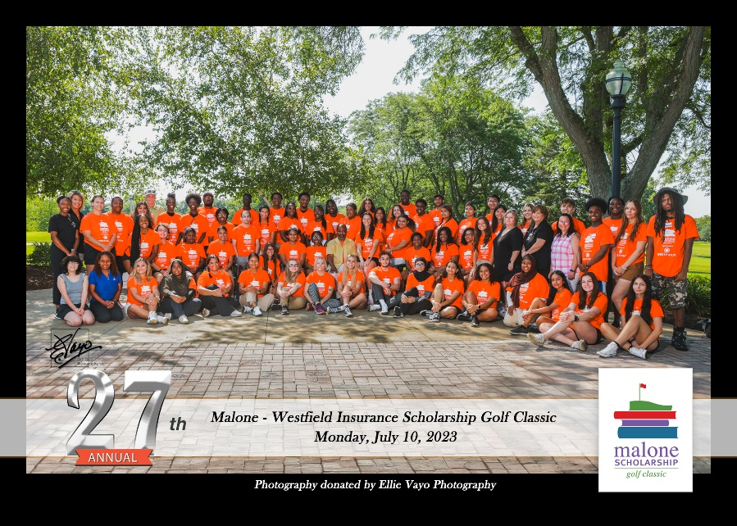

MALONE SCHOLARSHIP DONATION
Please make checks payable to :
Malone Scholarship At College Now
College Now Greater Cleveland is a 501(c)3 Corp

Name__________________________________________ Phone #____________________

Address_________________________________________________

City___________________________________ State__________ Zip_____________

DONATION AMOUNT $______________________

Call Jimmy if you have questions or need more information 440 520-3039

